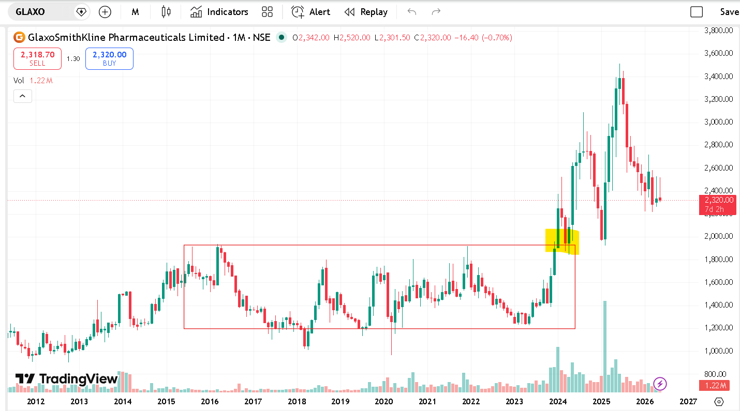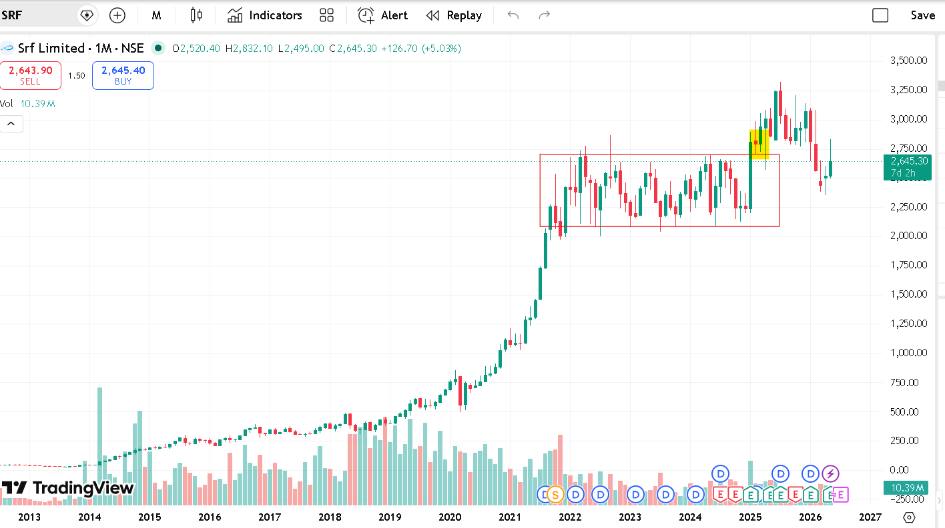

kiro ai pricing
Kiro AI offers a permanent free tier, with paid plans starting at $20/month. The platform uses a credit-based system, separating usage between "Vibe requests" (coding) and "Spec requests" (agentic planning). [1]
Kiro AI Pricing Plans
- Free: $0/mo. Includes 50 agentic requests per month.
- Pro: $20/mo. Includes 1,000 credits (divided into Vibe and Spec allocations).
- Pro+: $40/mo. Includes 2,000 credits to support heavier workloads.
- Power: $200/mo. Includes 10,000 credits, suitable for heavy spec-driven development teams. [1, 2, 3, 4, 5]
Overage Rates & Add-ons
If you run out of credits, paid tiers support flexible overages:
- Vibe requests: $0.04 per request.
- Spec requests: $0.20 per request. [1]
Trials and Bonuses
- Free Trial: All new users get a 14-day free trial containing bonus credits to test out both Vibe and Spec features.
- Sign-up Bonus: New users typically receive a 500-bonus credit trial upon their first sign-in (valid for 30 days). [1, 2, 3]
For exact feature breakdowns and to manage your subscription, visit the Kiro Pricing page or review your usage directly via the Kiro Billing Docs. [1, 2, 3]
8 sites
- Announcing new pricing plans and Auto, our new agent - Kiro
Table_title: Announcing new pricing plans and Auto, our new agent Table_content: | Free | Pro | Power | | --- | --- | --- | | $0 |

Kiro
- Billing for individuals - IDE - Docs - Kiro
Table_title: Tier comparison Table_content: | Tier | Credits | Overage | | --- | --- | --- | | Free | 50 | Not available | | Pro |
Kiro
- Kiro pricing update + waitlist invites coming soon
This new structure was shaped by observing how developers work, creating a more intuitive experience for our growing community. Th...

Kiro
Show all
You said: pro licencce in nir
The Kiro AI Pro license costs $20/month, which is approximately ₹1,660 INR to ₹1,670 INR per month depending on current currency exchange rates.
Core Plan Cost Breakdowns
- Base Price: $20/month (~₹1,665 INR).
- Included Allocation: 1,000 credits per month.
- Additional Overages: $0.04 per credit [1, 2]
You said: inr
The Kiro AI Pro license costs approximately ₹1,700 per month (equivalent to $20 USD).
Full Pricing Tier Breakdown in INR
- Free: ₹0/month.
- Pro: ₹1,700/month ($20/mo).
- Pro+: ₹3,400/month ($40/mo).
- Power: ₹17,000/month ($200/mo).
Estimated Overage Rates in INR
- Vibe requests: ~₹3.40 per request ($0.04).
- Spec requests: ~₹17.00 per request ($0.20).
Note: Final pricing in INR may vary slightly on your credit card statement depending on the live exchange rate and foreign transaction fees at the time of billing.
Would you like to know more about the international payment methods Kiro AI accepts, or how to set up spending limits to avoid overage charges?
Show Code
AI responses may include mistakes. For financial advice, consult a professional. Learn more
You said: puramate vanilla culinary essence use for ?
Puramate Vanilla Culinary Essence is primarily used as a concentrated flavouring agent to add a sweet, rich, and aromatic vanilla taste to a wide variety of desserts and beverages. Because it is highly concentrated, just a few drops are enough to mask the raw smell of eggs or flour and elevate the overall aroma of your dish. [1, 2, 3, 4]
You can purchase it directly from the Puramate Official Store or order it through grocery platforms like BigBasket. [1]
Primary Uses
- Baking: Essential for adding foundational flavour to sponge cakes, cookies, brownies, muffins, and cupcakes.
- Frostings and Icings: Mixed into buttercream, whipped cream, and royal icing to give them a classic vanilla taste.
- Desserts: Used in cold puddings, custards, fruit salads, and homemade ice creams.
- Beverages: Stirred into milkshakes, smoothies, cold coffees, hot chocolates, and lassis to enhance their fragrance.
- Confectioneries & Sweets: Added to homemade jams, jellies, syrups, and traditional Indian fusion sweets. [1, 2, 3, 4, 5]
Quick Tips for Best Results
- Dosage: Start with 1/2 to 1 teaspoon for a standard cake or batch of cookies. You can always adjust based on your taste preference.
- When to Add: In baked goods, cream it together with your butter and sugar or mix it into the wet ingredients to ensure the flavour distributes evenly.
- Storage: Keep the bottle tightly closed and store it in a cool, dry, and dark pantry away from direct sunlight to preserve its aroma. [1, 2, 3, 4, 5]
Are you planning to use it for baking or in a beverage? Let me know if you need a specific recipe measurement!
9 sites
- Puramate Culinary Essence Assorted 30ml Pack of 10
From the House of Puramate this Essence gives you Delicious taste and Flavour . If you are looking for the essential collection of...
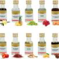
Amazon.in
- Puramate Culinary Essence - Vanilla 30 ml Bottle - BigBasket
Puramate Culinary Essence - Vanilla is a versatile product that can be used to add a delightful vanilla flavour to a variety of cu...
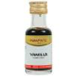
BigBasket
- Buy PURAMATE Culinary essence vanilla Online (30 ... - Swiggy
5% OFF. PURAMATE Culinary essence vanilla. Vanilla culinary essence. 30 ml. 38. 40. Explore all products from PURAMATE. Nutritiona...
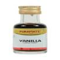
Swiggy
Show all
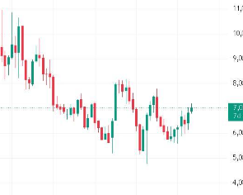
You said: how come its near 61.8% level fabo at 7060
The level of 7,060 serves as the 61.8% Fibonacci retracement because it is calculated mathematically using the absolute peak and valley of the major trend visible on your chart:
The Mathematical Formula
When measuring a retracement from a massive upward move, the formula to find the 61.8% golden ratio pullback is:
\(\text{Retracement\ Level}=\text{Macro\ High}-[0.618\times (\text{Macro\ High}-\text{Macro\ Low})]\)
The Inputs From Your Chart
By plotting the tool across the macro structure shown, you get these exact parameters:
- Macro High (Absolute Peak): 11,000 (visible at the top left of the price scale).
- Macro Low (Absolute Valley): 4,625 (the lowest downward wick visible near the bottom center).
The Calculation
- Find the Total Move: \(11,000 - 4,625 = 6,375\)
- Multiply by the Golden Ratio: \(6,375 \times 0.618 = 3,940\)
- Subtract from the Top: \(11,000 - 3,940 = \mathbf{7,060}\)
Because current price action (7,025) is hovering directly against this historical mathematical line, traders consider this a pivotal zone where selling pressure often exhausts and buyers look for structural support.
If you want to map this out yourself, would you like help calculating the 38.2% or 50% invalidation levels for this same macro trend?
Show Code
You said: yes
Based on the same macro trend spanning from the high of 11,000.00 down to the absolute low of 4,625.00 (a total move of 6,375.00 points), here are the calculated 38.2% and 50.0% retracement levels:
1. The 50.0% Retracement Level
- Formula: \(\text{Macro High} - (0.50 \times \text{Macro Range})\)
- Math: \(11,000 - (0.50 \times 6,375)\)
- Value: 7,812.50
- Trading Context: This represents the exact equilibrium or "fair value" midpoint of the entire market structure. Falling below this line was the first major signal that the bears were taking control of the macro trend.
2. The 38.2% Retracement Level
- Formula: \(\text{Macro High} - (0.382 \times \text{Macro Range})\)
- Math: \(11,000 - (0.382 \times 6,375)\)
- Value: 8,564.75
- Trading Context: In a strong bullish market, this is typically the shallowest pullback zone where buyers step back in. Because price failed to hold above 8,564.75 and broke aggressively lower, it invalidated the immediate bullish continuation structure and forced the market down toward the deeper 61.8% support zone where it sits now.
Summary Map for Your Chart
- Top (Trend Start): 11,000.00
- 38.2% Level: 8,564.75 (Bullish Invalidation)
- 50.0% Level: 7,812.50 (Midpoint Equilibrium)
- 61.8% Level: 7,060.00 (Current Major Support Zone)
- Bottom (Trend Anchor): 4,625.00
Would you like to analyze whether the current price action candle (at 7,025.00) shows signs of a bullish reversal or a continuation lower?
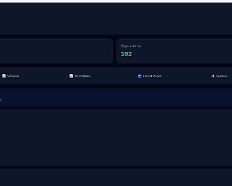
You said: this is my html page ,i want to look it more professional presentive in front of top 10 global clients (should be interactive with both ios browser and crome browser when telegram notification trigger and it open url)
To make this dashboard look highly professional for top-10 global clients and optimize it for instant mobile web rendering via Telegram links, you need to fix current visual hierarchies, design a dark-mode palette that screams premium, and implement responsive touch mechanics.
Here is an actionable roadmap to elevate the interface.

🚀 Critical Mobile & WebView Optimizations
When a user clicks a link inside Telegram (iOS or Android), it opens in an In-App WebView. This environment behaves differently than a standard desktop browser.
- Implement a Touch-First Layout: Replace hover-dependent states with distinct, explicit active/tap states. Mobile screens don't have hovers.
- Prevent WebView Scale Bugs: Add the strict mobile viewport tag to your <head> to prevent unintended double-tap zooming:
html
<meta name="viewport" content="width=device-width, initial-scale=1.0, maximum-scale=1.0, user-scalable=no">
Use code with caution.
- Optimize App-Like Performance: Use CSS properties like -webkit-overflow-scrolling: touch; to keep scroll containers buttery smooth on iOS Safari WebViews.
- Design Deep-Link Redirection: Ensure the triggered URL automatically appends an anchor tag or query parameter (e.g., ?stock=ATUL) so the page immediately scrolls to and highlights the target stock.

🎨 Visual & UI Design Enhancements
1. Premium Typography & Readability
- The Issue: Your current typography uses standard sans-serif system fonts with uniform weights, causing text to look cluttered.
- The Fix: Switch to premium tech font pairings like Inter or SF Pro (Apple's native system font).
- Implementation: Use bold, large formatting for primary tickers (ATUL) and reduce secondary stats (like target or 52W range) to a smaller, semi-transparent muted gray (rgba(255,255,255,0.6)).
2. Modern Card Layouts & Dynamic Spacing
- The Issue: The current cards use a dark border with a solid background, making the dashboard feel rigid and blocky.
- The Fix: Implement glassmorphism effects for modern enterprise look. Use subtle, semi-transparent backgrounds with thin, high-contrast borders:
css
background: rgba(30, 41, 59, 0.7);
backdrop-filter: blur(12px);
border: 1px solid rgba(255, 255, 255, 0.08);
border-radius: 16px; /* Smoother corner radius */
Use code with caution.
3. Professional Color Palette Refresh
- The Issue: The absolute black backgrounds mixed with high-saturation blues and neon greens look like a hobbyist tool rather than institutional-grade software.
- The Fix: Shift to a tailored slate-and-navy dark mode palette:
  - Main Background: Deep Slate Blue (#0F172A)
  - Card Background: Dark Navy (#1E293B)
  - Primary Active Button: Royal Cyan-Blue (#2563EB)
  - Bullish/Target Signals: Soft Emerald Green (#10B981) instead of toxic bright neon.
4. Filter Tags & Quick-Action Tabs
- The Issue: The current horizontal menu uses small icons with checkbox inputs that feel clunky on mobile devices.
- The Fix: Convert them into sleek pill-shaped toggle buttons. The active filter (e.g., Fibonacci) should glow with a subtle box-shadow, while inactive tabs remain flat and clean.

💡 Suggested Layout Structure (Before vs. After)
Element | Current Design | Executive Redesign
Header Metrics | Square borders, plain bold text | Compact cards, distinct icon indicators, large tracking numbers
Stock Rows | Text aligned loosely inside a large row | Split layout: Left side shows corporate ticker/sector tag; Right side shows dynamic pricing with real-time green/red indicator pills
Live Indicator | Simple text marker | Pulsing green dot animation (animation: pulse 2s infinite;) next to crisp, clean text

🛠️ Next Steps
Would you like me to write the clean HTML & Tailwind CSS production code for the updated responsive mobile layout, or should we design the Telegram deep-linking script to automatically highlight the right stock row upon opening?
You said: why kiro just giving 50 free token before it was giving 500
The reduction in free credits occurs because Kiro ended its limited-time promotional welcome bonus and formally structured its permanent Kiro Free Tier to include exactly 50 credits per month. [1, 2, 3, 4]
The Reason for the Change
- The 500 Credits Were a Temporary Bonus: When Kiro removed its waitlist, they gave out a limited-time signup bonus of 500 free credits (valid for 30 days) so new users could test the system.
- Abuse and Exploitation: Many users were bypassing the limits by creating dozens of burner GitHub or Google accounts to continually farm the 500 free credits. To protect their systems from fraud, Kiro cracked down on automated accounts and restructured their tiers.
- Shift to Paid Tier Bonuses: On May 8, 2026, Kiro officially updated its policy. New free accounts no longer receive the 500 upfront signup credits. Instead, they shifted those bonus incentives toward users who subscribe to the $20/month Pro tier, where open-weight and frontier models can be fully utilized. [1, 2, 3, 4, 5]
Current Kiro Tier Structure
If you need more capacity, you have a few options based on their official Pricing Policy:
- Kiro Free ($0/mo): 50 standard credits per month, with access to open-weight models and limited use of Claude Sonnet.
- Kiro Pro ($20/mo): Includes 1,000 monthly credits and full model access.
- Kiro for Students: If you are a university student, you can apply to get 1,000 credits per month free for one year. [1, 2, 3, 4, 5]
If you are a student or a startup developer, let me know! I can guide you on how to apply for Kiro Student Credits or the Startup Program to get your higher limits back. [1, 2]
AI can make mistakes, so double-check responses
11 sites
- More room to explore: $20 paid tier sign-up bonus - Kiro
8 May 2026 — Signing up to the free tier doesn't require a credit card. Usage on the free tier is rate limited and subject to a weekly quota. C...
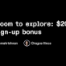
Kiro
- Frequently Asked Questions - Kiro
Kiro offers flexible pricing tiers designed around how developers use Kiro. New users can start with the perpetual Kiro Free tier,

Kiro
- Kiro seems to have gone amok - Homo Ludditus
28 Mar 2026 — What's up with the dysfunctional nonsense newly introduced auto-banning system? So you are a newly registered user account, you ge...

Homo Ludditus
Show all
You said: yes
To get your higher limits back, you can apply for the Kiro Student Discount or the Kiro Startup Program.
Kiro Student Program (1,000 Free Credits/Month)
If you have a valid university email, you can get 1,000 monthly credits free for one year.
- Step 1: Go to the official Kiro Education Portal.
- Step 2: Log in using your GitHub account connected to the GitHub Student Developer Pack.
- Step 3: Alternatively, upload your school ID or official transcript showing current enrollment.
- Step 4: Submit the form; approval usually takes 24 to 48 hours.
Kiro Startup Program (Up to $2,000 in Credits)
If you are building a product, Kiro provides heavy subsidies for early-stage companies.
- Step 1: Navigate to the Kiro for Startups application page.
- Step 2: Provide your company website and a brief description of your product.
- Step 3: Link your pitch deck or proof of incorporation if available.
- Step 4: Approved startups receive $500 to $2,000 in active platform credits.
To help you get the right approval, tell me:
- Are you applying as a student or a startup founder?
- Do you have an active GitHub Student Developer Pack?
I can give you the exact links and application text to ensure you get approved quickly.
AI responses may include mistakes. For financial advice, consult a professional. Learn more
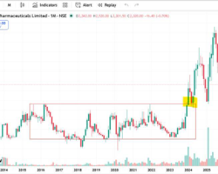
You said: it called darvex box ?
Yes, it is closely related, but the correct term is a Darvas Box (named after its creator, Nicolas Darvas). [1]
The red rectangle drawn on your TradingView India chart represents a classic multi-year consolidation range. When the stock price finally breaks above the top boundary of that box (as highlighted by your yellow marker in early 2024), it triggers a powerful momentum breakout signal. [1, 2]
How the Darvas Box Strategy Works
- Identify the Range: The stock tracks sideways, establishing a clear ceiling (resistance) and floor (support) over a prolonged period.
- The Breakout Signal: A buy signal is generated when a candle cleanly closes above the top boundary of the box on high trading volume.
- Setting the Stop Loss: Once the price breaks out into a higher "box," the previous top boundary typically turns into the new floor. Traders often place their risk management stop-loss order right below this line to protect their capital. [1, 2, 3, 4]

